**DAILY ONLINE ACTIVITIES SUMMARY**

|  |  |  |  |  |  |  |  |
| --- | --- | --- | --- | --- | --- | --- | --- |
| **Date:** | **13/06/2020** | | | | **Name:** | **ROHAN VASHISTA BM** | |
| **Sem & Sec** | **6th Sem & B** | | | | **USN:** | **4AL17CS078** | |
| **Online Test Summary** | | | | | | | |
| **Subject** | | **PAP IA-4 TEST** | | | | | |
| **Max. Marks** | | **30** | | **Score** | | **22** | |
| **Certification Course Summary** | | | | | | | |
| **Course** | **Python 3** | | | | | | |
| **Certificate Provider** | | | **SoloLearn** | **Duration** | | | **5hrs** |
| **Coding Challenges** | | | | | | | |
|  | | | | | | | |
| **Status: completed** | | | | | | | |
| **Uploaded the report in Github** | | | | **yes** | | | |
| **If yes Repository name** | | | | <https://github.com/Rohanvasista/Coding-activities> | | | |
| **Uploaded the report in slack** | | | | **yes** | | | |

**ONLINE TEST DETAILS**

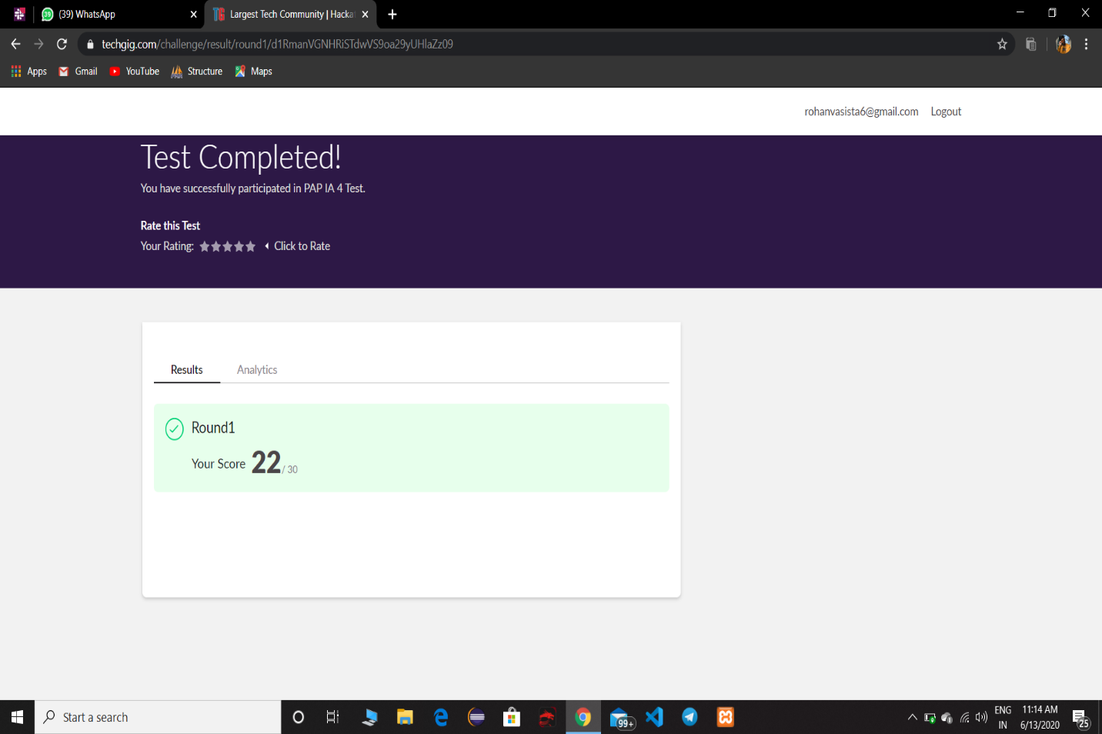

**CERTIFICATION DETAILS**

**Modules completed**

* Control structures
* Lists
* While loops
* Operator
* For loops

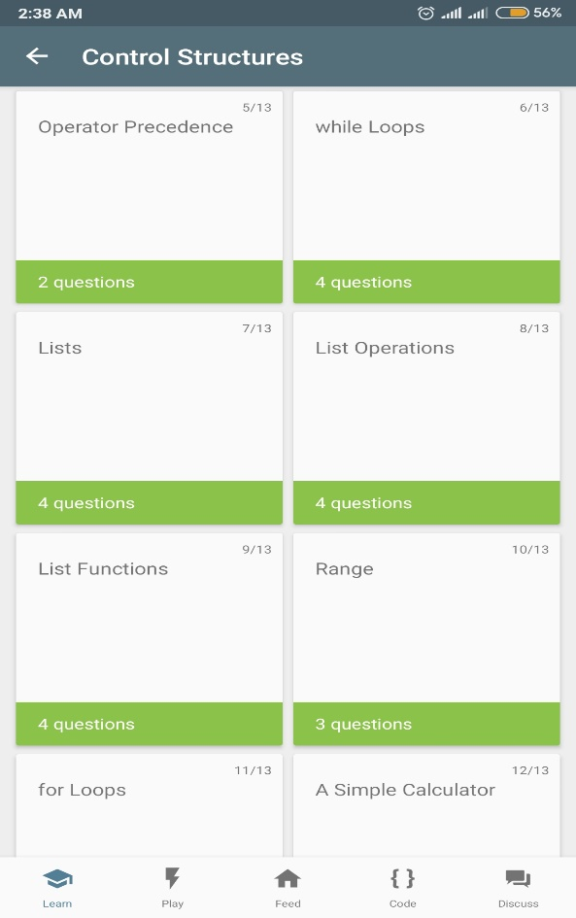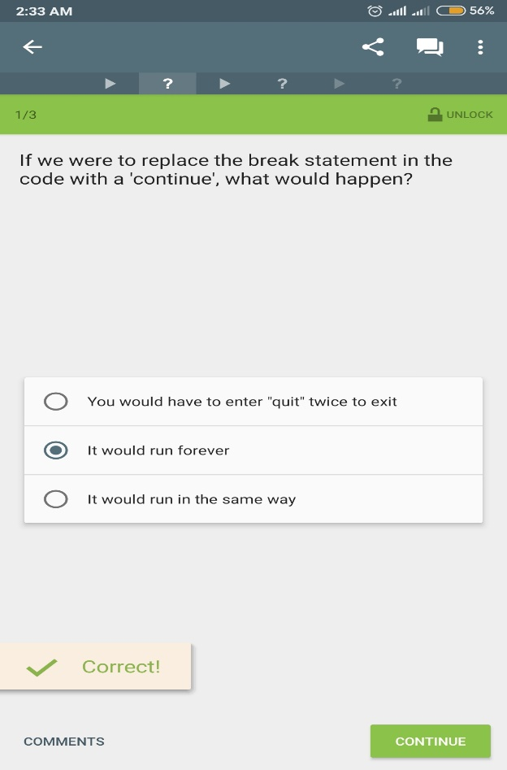

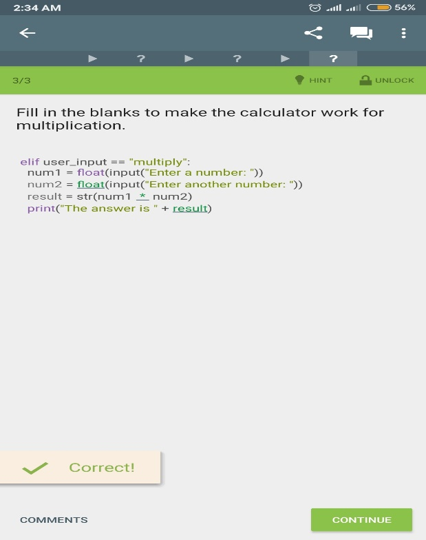

**Coding Challenge Details**

**1**. Java Program to determine whether a given matrix is a sparse matrix

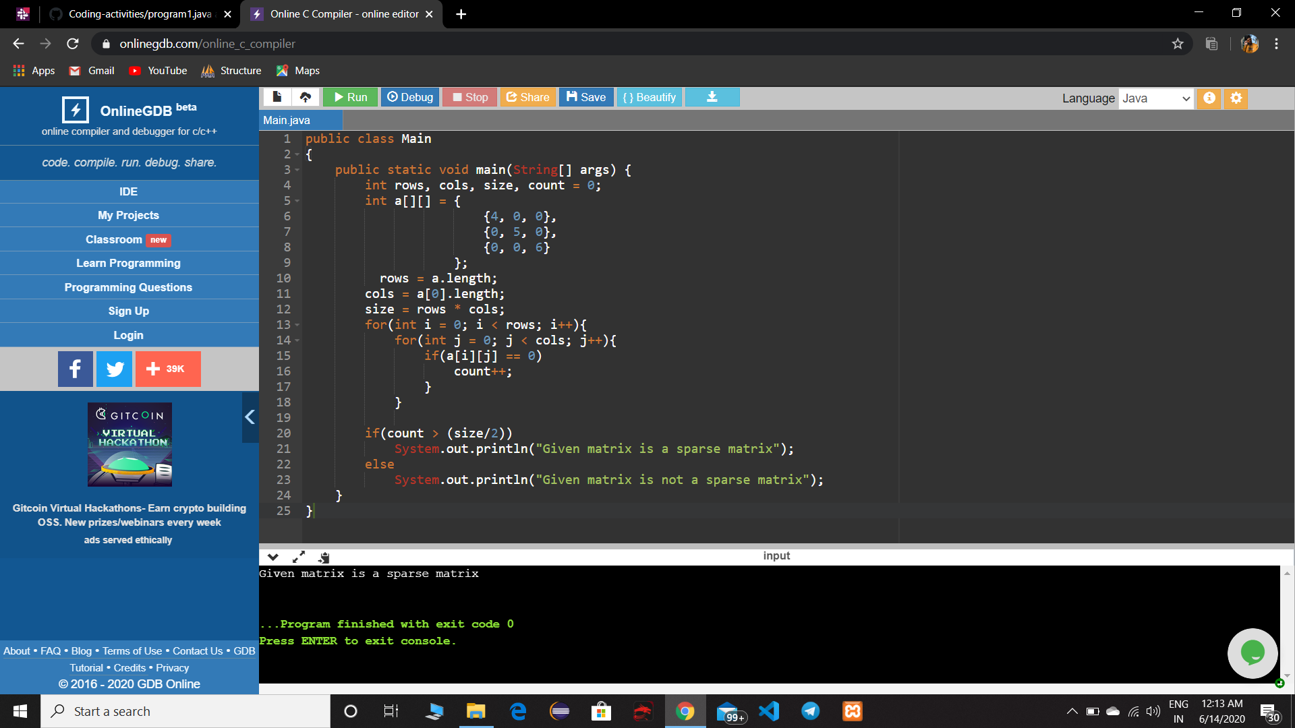

**2.** Python Program to print the pattern of alphabets



  
  
  
  
  